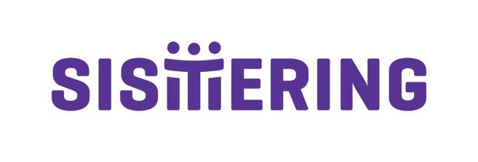

Board of Directors Application Form

Name:

Address:

Phone:

Mobile:

Email:

- Why are you interested in joining Sistering’s Board of Directors? (200 words max)

- How do you feel your skills and experience could benefit the Sistering Board? (200 words max)

- Sistering is guided by the principles of anti-racism/anti-oppression, equity, access, social advocacy, being trans inclusive, trauma informed, and practicing harm reduction. How do you see this fitting in with your role on Sistering’s Board of Directors? (400 words max)

- What amount of time are you able to give to Sistering on a monthly basis (e.g. hours per month)? Is there anything that would prevent you from fulfilling your volunteer commitment to the Board? (200 words max)

- Please describe any experience you have with nonprofit volunteer Boards. (200 words max)

Please send the completed application with a CV/resume by August 27, 2021 to mdelanerolle@sistering.org and include Board Application in the subject line of your email or drop off a copy to Sistering at 962 Bloor Street West, Toronto, ON M6H 1L6.
We thank all applicants for their interest in this position, however we will only be contacting those selected for interviews.

